|  |  |
| --- | --- |
| **Nikon Z7 II Camera**  Máy ảnh Nikon Z7 II (Body Only)  nikon-z7-ii nikon-z7-ii-8 nikon-z7-ii-4 nikon-z7-ii-7 | **Featured information:**   * EXPEED 6 image processor * BSI CMOS FX 45.7MP sensor * Continuous shooting at 10 fps, ISO 64-25600 * UHD 4K60 Video Recording   Price: 2500$  **Specifications:**   * **Sensor Format:** Full-Frame (1x Crop Factor) * **Resolution:** Actual: 46.89 Megapixel/ Effective: 45.7 Megapixel * **Size photo:** 8256 x 5504 * **Image Proportions:** 1:1, 3:2, 4:5, 16:9 * **Sensor Type:** CMOS * **Image Format:** JPEG, Raw * **Anti-Vibration:** No * **Lens Mount:** Nikon Z |

**Description:**

#### **The strong, powerful design of the Nikon Z7 II**

Retaining the same robust design as the previous two Z-mount cameras, the Z7 II is mostly made from durable magnesium alloy, for extreme weather resistance. Support photographers to shoot in all different conditions while ensuring the best image and video quality. With a deep grip, the Nikon Z7 Mark II feels sturdy, comfortable handheld photography. At the same time, possessing a flexible compact size that allows users to carry the camera with them anywhere is very convenient without worrying about bulky and difficult when moving.

#### **Design of Nikon Z7 II**

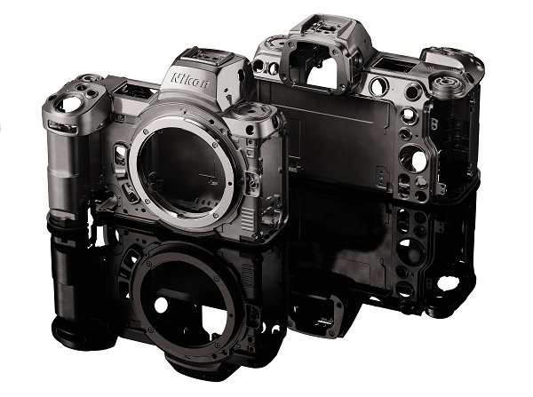

#### **45.7MP CMOS sensor and Dual EXPEED 6 Image Processor**

Using a 45.7MP BSI CMOS sensor, this mirrorless camera delivers impressive high-resolution imaging capabilities. The wide sensor size captures more light, supporting bright images even in low-light conditions. Offering an expandable ISO range of up to 64 – 25600 combined with back-illumination technology, the Nikon Z7 II effectively eliminates image noise when shooting with high sensitivity. In contrast to low sensitivity, the camera enhances color contrast, resulting in vivid, realistic images.

